

**Assignment on Pseudo Code & Flow Chart**

Course Name: Structure Programing

Course code: CIS-115

**Submitted by**

Nabila Sarkar

ID:222-16-675

Section:A

Department of CIS, DIU

**Submitted to**

Abdullah Bin Kasem Bhuiyan

Faculty of Science and Information Technology

Daffodil International University

***Problem 1: your father know that you are a good at programming now he is asked you to write a C program that can take input the age of your father , mother & uncle and your program should output who is the oldes, who is youngest and whose age is between oldest and youngest***.

Step 1: Declare variable (Father age ,Mother age ,Uncle age)to store integer value.

Step 2: Display the message to enter ( Father age ,Mother age ,Uncle age);

Step 3: Taking output a variable (Father age ,Mother age ,Uncle age);

Step 4:

If(uncle>father && uncle>mother);

Step 5:Print output (“uncle is oldest person”);

Step 6:

If(uncle>mother && father>mother);

Step 7:Print output (“mother is youngest person”);

Step 8:

If(uncle>father && father>mother);

Step 9:Print output (“your father’s age between oldest and youngest age”);

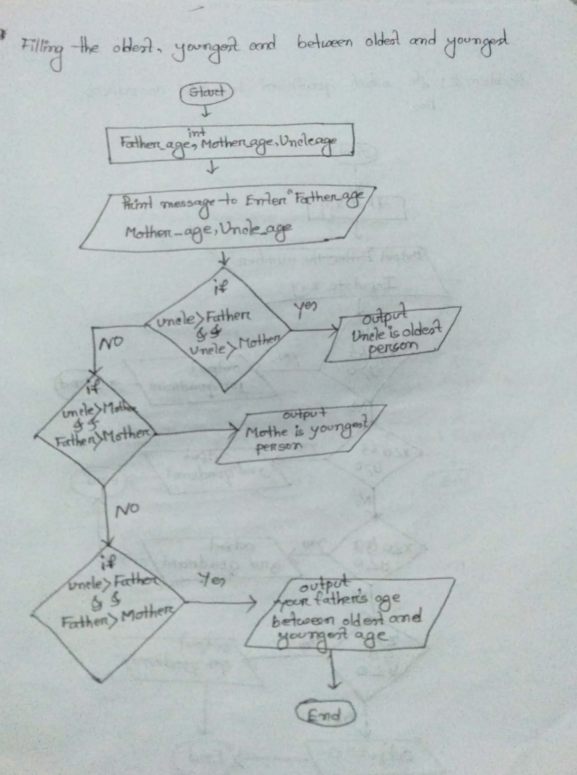Step 10 :end.

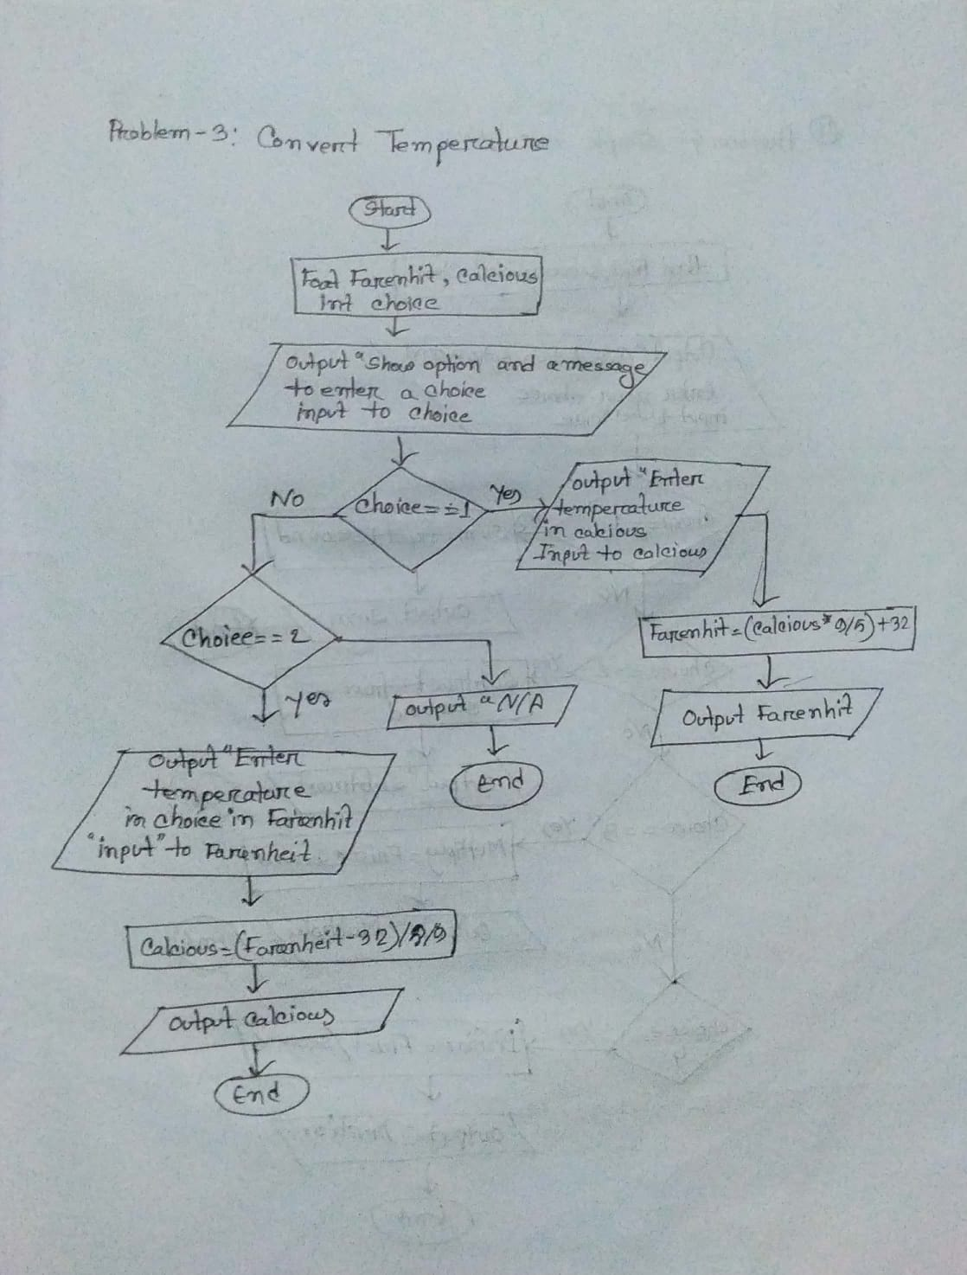

***Prpblem2: This is c program We know there are four quadrants named 1st,2nd ,3rd and 4th quadrant .your task is to write a c program that can take input of the values of x & y coordinates lies***

Step 1: Declare variable (X,Y)to store integer value.

Step 2: Display the message to enter X coordinate point.

Step 3:Input X variable;

Step 4: Display the message to enter Y coordinate point.

Step 5:Input Y variable;

Step 6:Check

If(x>0 && y>0);

Step 5:Output (“Inputted coordinate lies is the 1st Quadrant”);

Step 6:Otherwise

else if(x<0 && y>0);

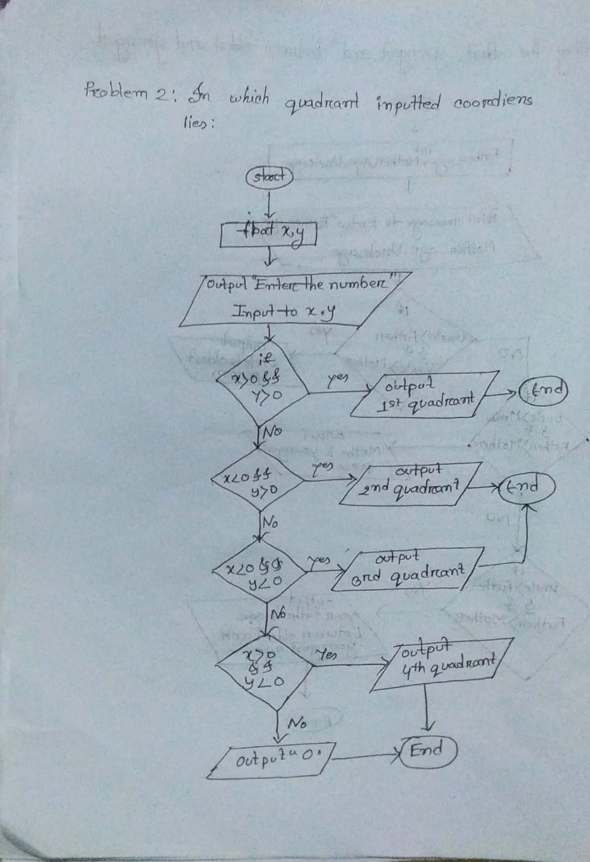Step 7: output (“Inputted coordinate lies is the 2nd Quadrant”);

Step 8: otherwise

Else If(x<o && y<0);

Step 9:Output (“Inputted coordinate lies is the 3rd Quadrant”);

Step 10:Otherwise

If(x>o && y<0);

Step 11:Output (“Inputted coordinate lies is the 4th Quadrant”);

Step 10 :Otherwise

Output “0”

Step 11: End

***Problem3: A C program that can convert temperature from degree celcius to farenheit and***

***farenheit to celcius.***

Step 1: Declare variable (farenhit,calcious)to store fractional value (Choice) tó store numeric value.

Step 2:Show the option and a message to enter a choice .

Step 3:Taking Input variable(choice)

Step 4:Check

If(choice==1)

Step 5:Display enter temperate in calcious

Step 6:input into Calcious variable

Step 7:Calculatiovn,

Farenheit =(calcious *9/5)+32

Step 8:print output “Temperature in farenhit”

Step 9:otherwise,

else If(choice==2)

Step 10:Display enter temperate in farenheit

Step 11:input into farenheit variable

Step 12:Calculatiovn,

Calcious=(farenheit-32)*5/9;

Step 8:print output “Temperature in Calcious”

Step 9:Otherwise

Step 10:Print output “N/A”

Step 11: End

***Problem4:A C program simple calculation sum,subtract, multiply, divide.***

Step 1: Declare variable (frist ,secound)to store fractional value (choice) to store numaric value.

Step 2:Show the option for calculation and a message to enter a choice

Step 3:Taking Input variable(choice)

Step 4:Check If(choice==1)

Step 5: Output”sum”,frist+second;

Step 6:otherwise ,(choice==2)

Step 5: Output”subtract”,frist-second

Step 7:otherwise ,(choice==3)

Step 8: Output”multiply”,frist*second

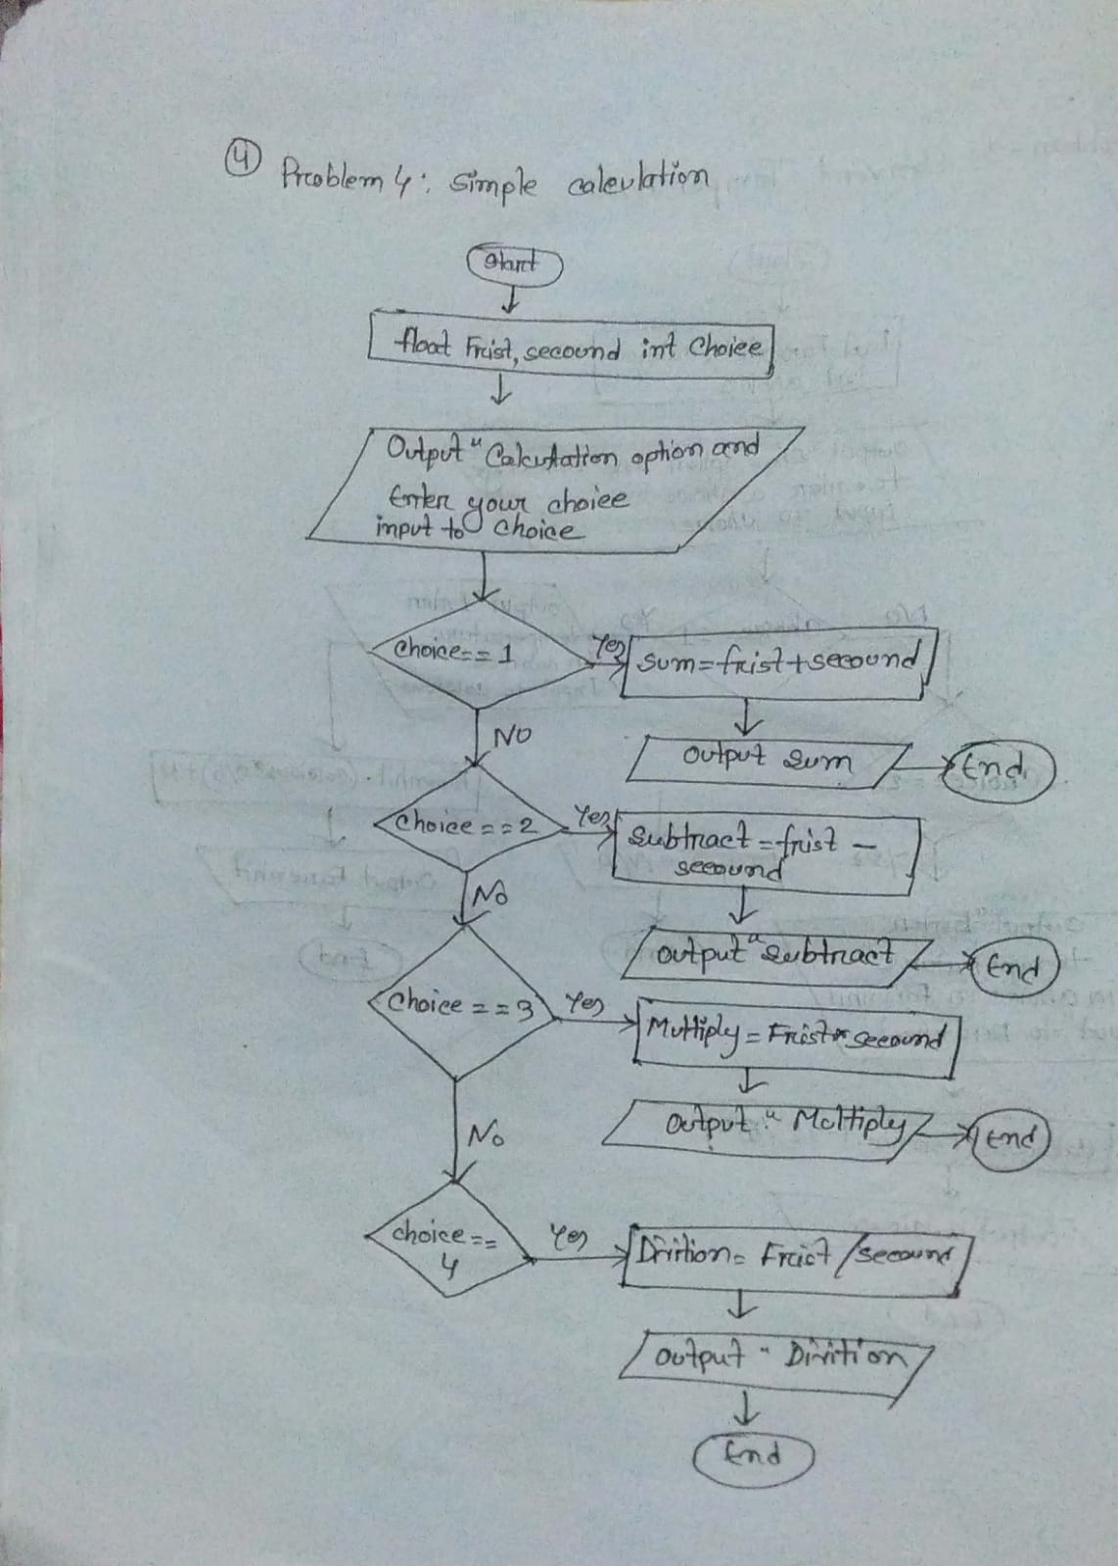Step 9:otherwise ,(choice==4)

Step 10:Output”Devition”,frist/second

Step 11: End

**(Problem 5)(2.1) Changing the value of an integer:**

1. Declare variable (currentNumber) to store numeric value.

2. Show a message to enter the number.

3. Input to currentNumber variable.

4. Check if (currentNumber%2)!=0

5. Output “The new value”, (currentNumber*3)+1.

6. Otherwise

7. Output “New value”, currentNumber/2.

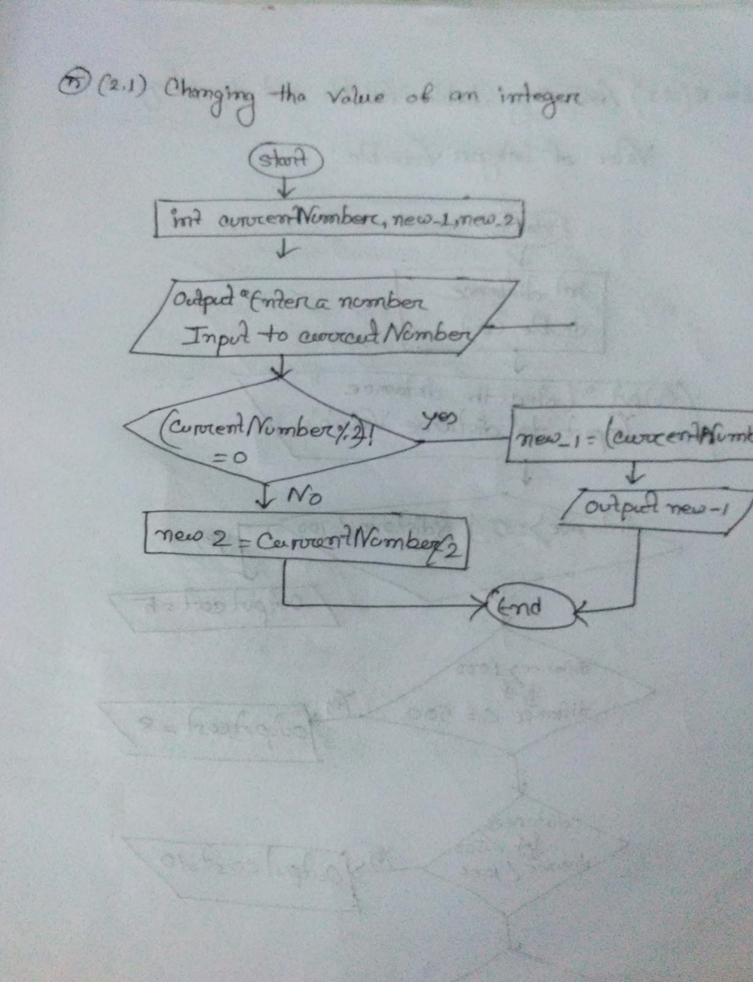

**(Problem 5)(2.2) Assigning double variable cost depending on the value of integer variable:**

1. Declare variable (distance) to store numeric value and variable (cost) to store fractional value.

2. Show a message to enter the distance.

3. Input to distance variable.

4. Check if distance>=0 && distance<=100

5. Output “Show cost”, cost=5.

6. Otherwise if distance>100 && distance<=500

7.Output “Show cost”, cost=8.

8. Otherwise if distance>500 && distance<1000

9. Output “Show cost”, cost=10.

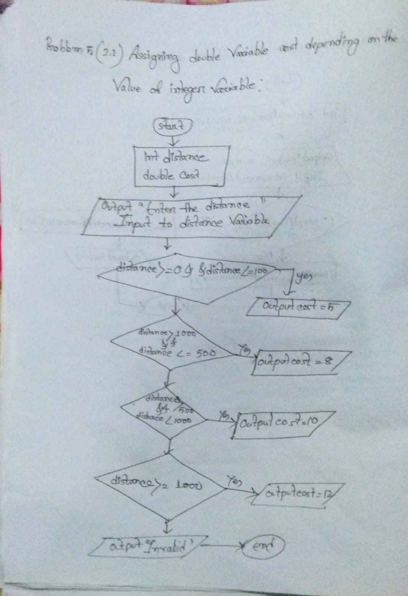10. Otherwise if distance>=1000

11. Output “Show cost”, cost=12.

12. Otherwise

13. Output “Invalid!”

**(Problem 6) Leap year calculator:**

1. Declare variable (year) to store numeric value.

2. Show a message to enter the year.

3. Input to year variable.

4. Check if (year%4==0 && year%100!=0) || year%400==0

5. Output “Leap year”.

6. Otherwise

7. Output “Not Leap year”.

8.end

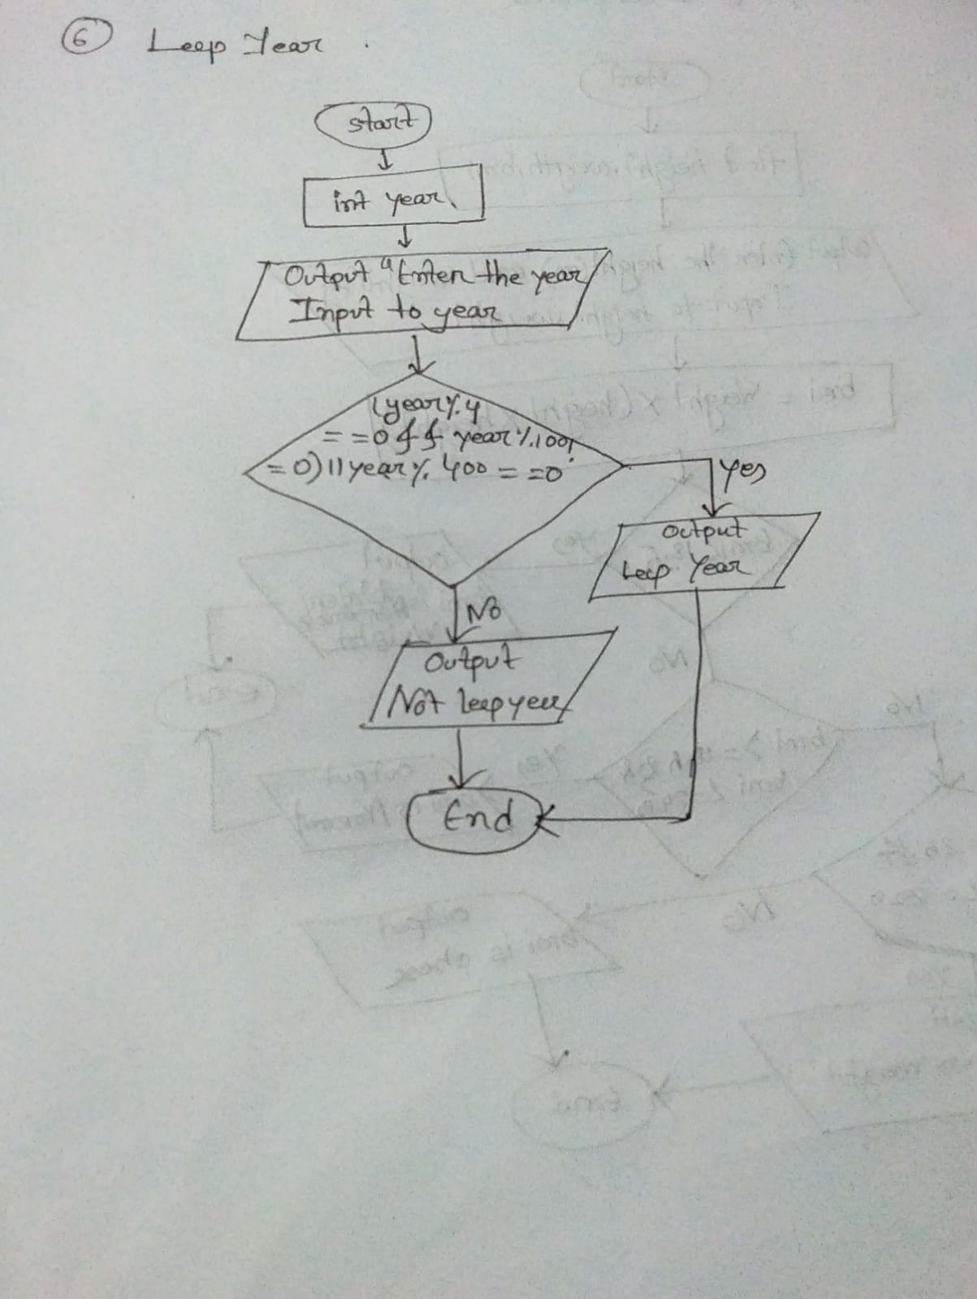

**(Problem 7) BMI calculator:**

1. Declare variable (height, weight, bmi) to store fractional value.

2. Show a message to enter the weight in kg.

3. Input to weight variable.

4. Show a message to enter the height in meter.

5. Input to height variable.

6. Compute bmi=weight/(height*height).

7. Check if bmi<18.5

8. Output “Show bmi and weight status: Underweight”, bmi.

9. Otherwise if bmi>=18.5 && bmi<=24.9

10. Output “Show bmi and weight status: Normal”, bmi.

11. Otherwise if bmi>=25 && bmi<=29.9

12. Output “Show bmi and weight status: Overweight”, bmi.

13. Otherwise

14. Output “Show bmi and weight status: Obese”, bmi.

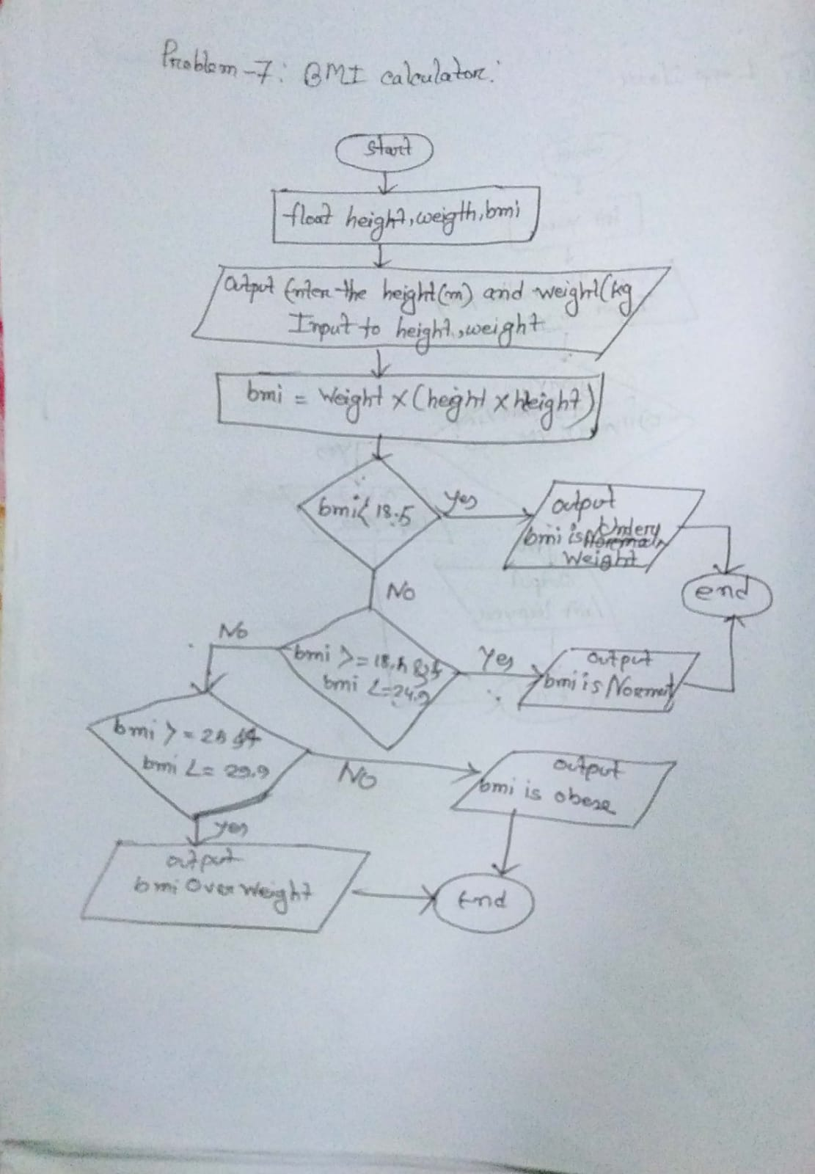**15.end**

**Problem 8.Write a program to find the total number of illitegacy men women if the population of the town**

1. Declare variable (town population) to store integer value.

2. Display the message to enter ( town population )

3.Taking input to variable

4.Calculation, men=(population*52)/100;

women=population-men;

men_and_women_literacy=population-men;

men_literacy=(men*35)/100;

men_illiteracy=men-men_literacy;

women_literacy=men_and_women_literacy-men_literacy;

total_literacy=population-men_and_women_literacy;

women_illiteracy= total_literacy-men_literacy;

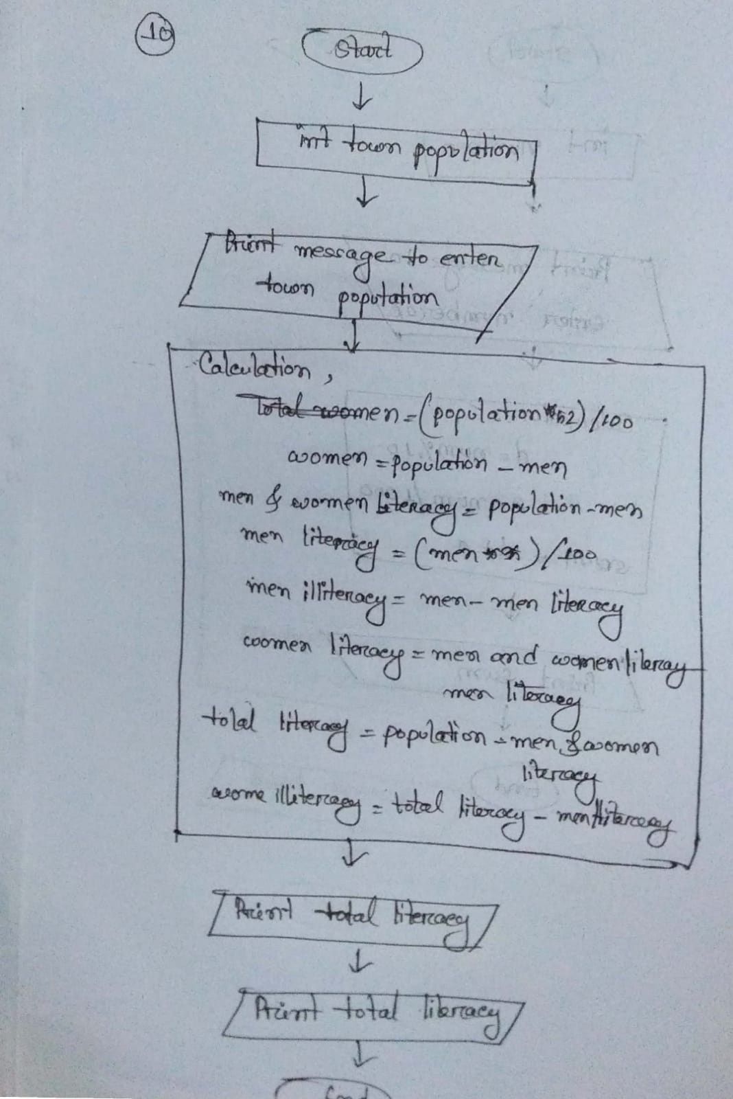5.Print Output total literacy

6.Print output women illiteracy

7.end

**Problem 9:Curreny**

1. Declare variable (currency) to store integer value.

2. Display message to enter ( currency)

3 3.Taking input to variable

4.Calculation,

Hundred tk=amount/100;

amount=amount%100;

fifty_tk=amount/50;

amount=amount%50;

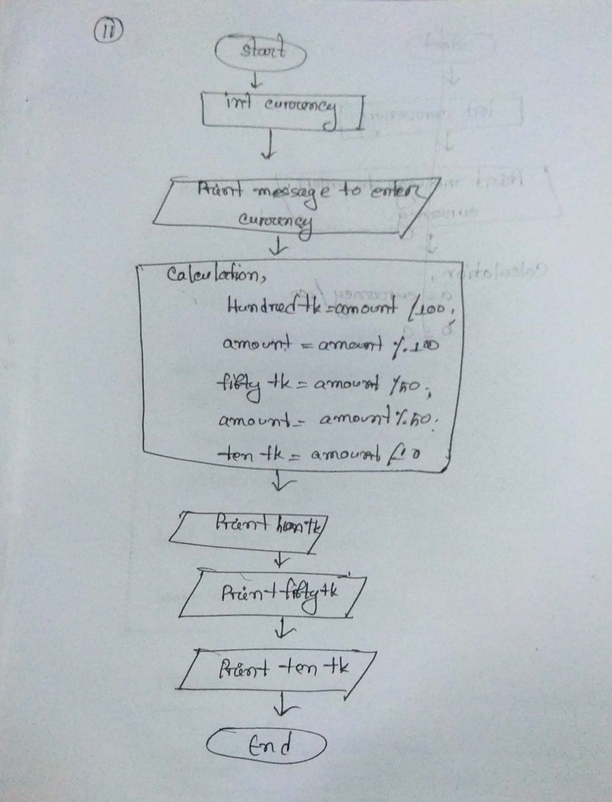ten_tk=amount/10;

5.Print output hun_tk

6. Print output fifty_tk

7. Print output ten_tk

8.end